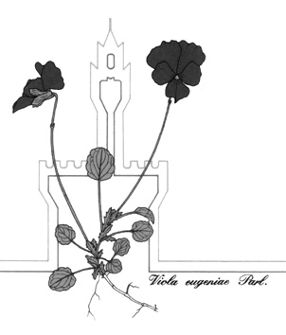

Società Botanica Italiana onlus
120° Congresso della Società Botanica Italiana onlus

Xi International Plant Science Conference (IPSC)

DISCLAIMER

I, …………………………..………………………………………………………

AUTHORIZE

the Scientific Committee of the 120th Congress SBI to use to use the abstract and/or the poster in pdf and jpg format
entitled _________________________________________________________________________________
_______________________________________________________________________________________

presented during the Congress for any disclosure in paper or electronic form on internet sites of scientific interest and to be delivered to the participants during the Congress.

DECLARES

- - that the texts, images, videos and more contained in the abstract are free from copyright restrictions;
- that the text content is shared by all the authors indicated.

The material will be distributed free of charge without any view to profit.

Date _______________ Signature __________________________________________

Complete and submit at the time of submission of the abstract

